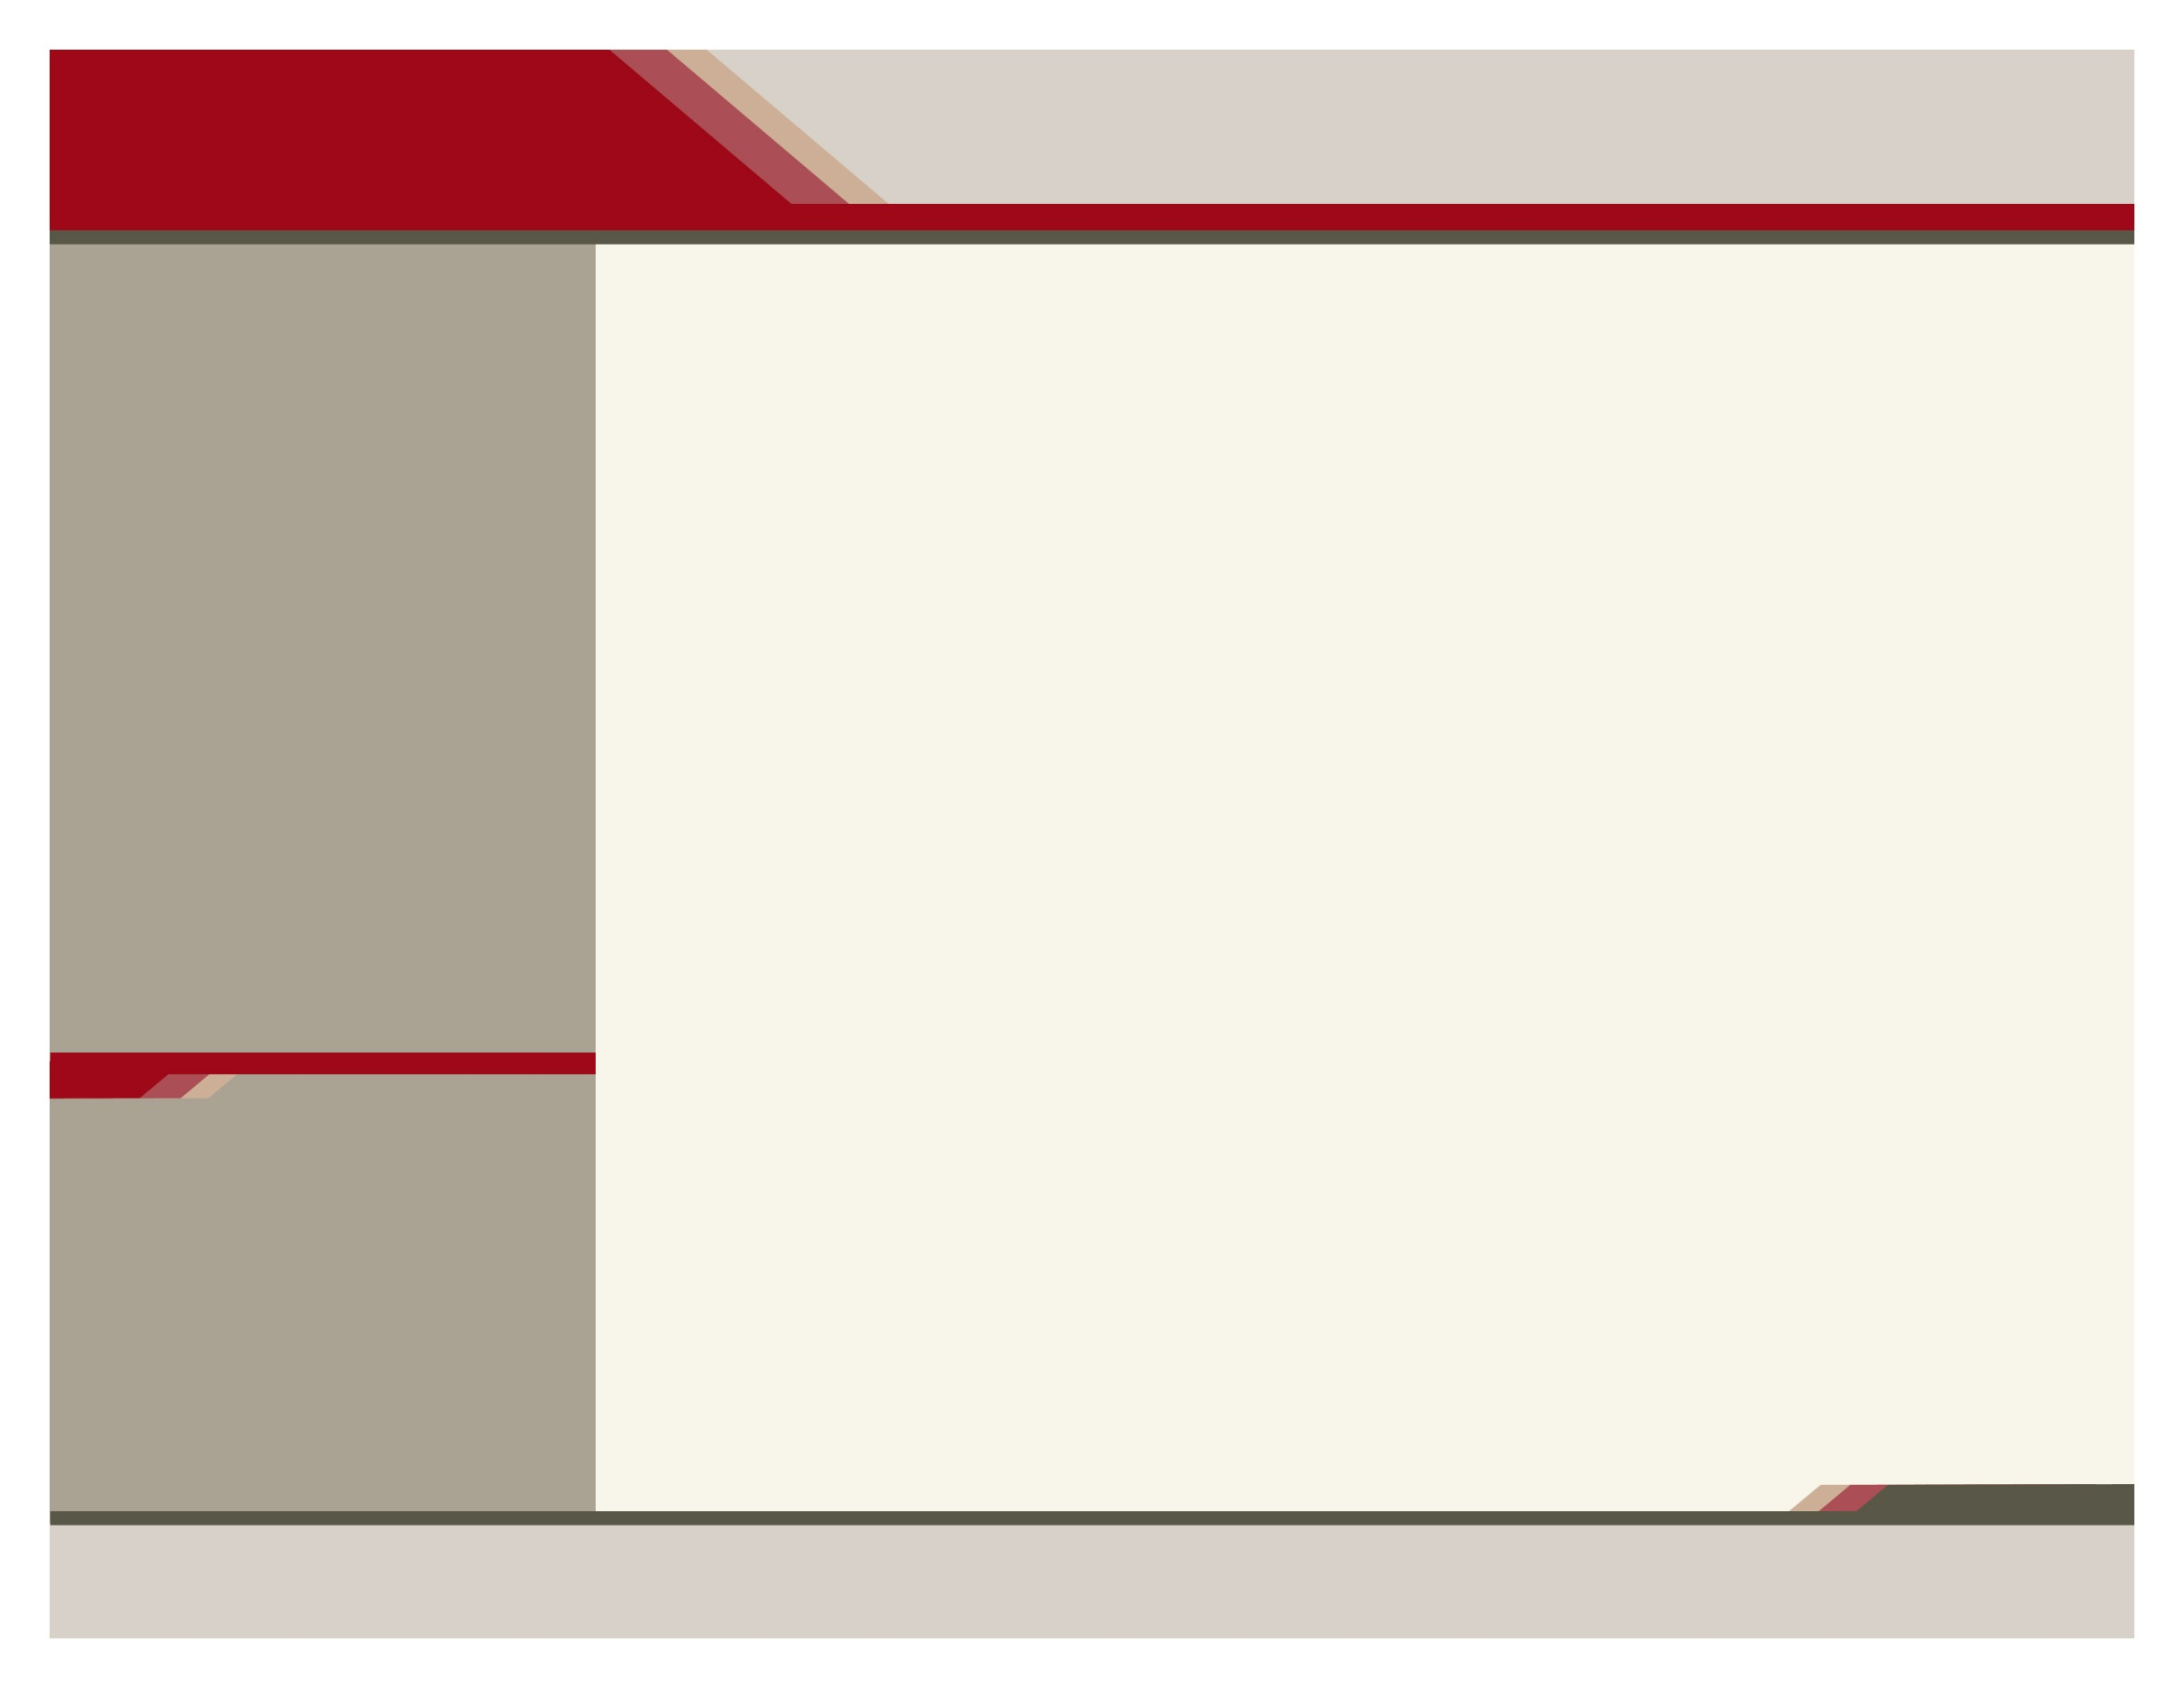
Training Details

July 10 – 13, 2017

NO Registration Fee - Participants are responsible for their travel, time, lodging and any other expenses.

A MANDATORY online course will need to be completed prior to the four day, in-person training. More information will be provided after registration. 5 CEUS will be provided by CAPT upon completion of the online course.

A Certificate of Attendance for 26 hours will be provided by the Department upon completion of the face-to-face training. The 31 hours (5 hours from the online course and 26 from the in-person training) will count towards the 40 hours needed for the Prevention Specialist in Training certification.
Hotel
Grand Lodge Waterpark Resort
805 Creske Ave., Rothschild, WI 54474
Ph: 1-715-241-6300
Please request a room in the “WI DHS SAPST” block to receive the $82.00 a night rate. Room block is available from Sunday, July 9 – July 12. The room block deadline is June, 9, 2017.

Training Site
Royal Oak Room
Grand Lodge Waterpark Resort
805 Creske Ave., Rothschild, WI 54474

SAPST
Building Our Behavioral Health Workforce
Substance Abuse Prevention Skills Training (SAPST) for American Indians and Alaska Natives

What does the SAPST prepare practitioners to do?
- Address substance abuse prevention in the context of behavioral health.
- Improve practice by developing a comprehensive approach to prevention guided by the Substance Abuse and Mental Health Services Administration’s (SAMHSA) Strategic Prevention Framework.
- Reduce behavioral health disparities by identifying the needs of vulnerable populations and improving cultural competency.
- Sustain prevention by collaborating effectively across sectors to address shared risk factors and improve the health and well-being of communities in a cohesive way.

The SAPST is a foundational course of study in substance abuse prevention. Innovative training that blends a five-hour, self-paced online module, and followed by a four- day/26-hour interactive, in-person training.

An advisory team of Native practitioners adapted the training to better reflect Native culture, experiences, and learning styles. For example, the adapted SAPST allows more time for discussion than the original training, and grounds the training content in 'tribal realities' such as role of the Tribal Council in guiding prevention decisions and 'talking circles' as a key approach to collecting and sharing information.

The SAPST is key to building the workforce capacity of the state and tribes.

• This innovative training, combining online and in-person components, offers American Indian/Alaska Native practitioners a comprehensive introduction to the substance abuse prevention field.

• Develop skills needed to apply this information to daily work.

• Detailed guidance for implementing each of the five steps of SAMSHA’s Strategic Prevention Framework (assessment, capacity building, planning, implementation and evaluation).

What is the Substance abuse prevention skills training?
Registration will be ‘first come, first served’ basis and registration will be capped at 20 participants.

Wisconsin Department of Health Services | 1 W. Wilson St., Rm. 850, Madison, WI 53703 | phone 608.267.3783 | fax 608.266.1533

SAPST Registration Form
Wisconsin Department of Health Services | 1 West Wilson St., Rm. 850, Madison, WI 53703 | phone 608.267.3783 | fax 608.266.1533

Enter Contact Information Here | 1127 Lombard Blvd. San Francisco, CA 59802 | phone 555.555.5555 | fax 555.555.5555
Enter Contact Information Here | 1127 Lombard Blvd. San Francisco, CA 59802 | phone 555.555.5555 | fax 555.555.5555
July 10-13, 2017

Please return Registration Form by June 23, 2017.
Raina Haralampopoulos– Mary.Haralampopoulos@wi.gov
1 West Wilson Street, Room 850
Madison, WI 53703
FAX: 608-266-1533

***TRAINING EXPECTATION – Participants MUST attend ALL four days of the Training.***

- Name (Last, First MI.) | - Title/Position
- Agency

- Address (Street, City, State, Zip) | - County/Tribe
- E-mail address | - Telephone Number
- Please specify any dietary needs:

Thank you for registering and you will receive confirmation of your registration as soon as possible.
If you have any questions or concerns please contact Raina Haralampopoulos at Mary.Haralampopoulos@wi.gov

