December 1, 2016 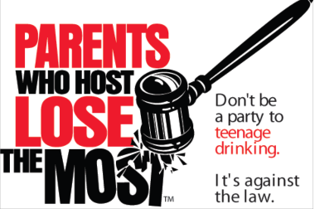
Dear Prospective Applicants:
Welcome to the 2017 Wisconsin Parents Who Host, Lose the Most: Don’t be a Party to Teenage Drinking campaign. As you know, underage drinking is illegal. It has long-term health consequences and is one of the leading causes of death among youth. The Parents Who Host (PWH) campaign promotes safe prom and graduation events by discouraging underage drinking parties hosted by parents, family, and friends.
Applicants should be prepared to implement the following:
- PWH public information campaign.
- Media advocacy and outreach such as press releases and presentations to civic groups.
- Law enforcement support, including targeted operations to prevent teenage drinking parties such as alcohol age compliance checks or patrols at identified locations where underage drinking occurs.
These three activities reduce the availability of alcohol and underage alcohol abuse during prom and graduation celebrations.
The application process begins Thursday, December 1, 2016. Please submit your completed application no later than Friday, December 16, 2016, to Chino Amah Mbah at Chino.AmahMbah@dhs.wisconsin.gov. A confirmation email will be sent when your application is received. Applications received after December 16 will be given consideration for acceptance only if materials are available.
Applicants may target a portion of a community, such as the area around a specific school, a neighborhood, or an entire community. The applicant will receive PWH promotional material at no cost. Information on determining the amount of materials your community is able to apply for is included in the application.
The following is the timeline for the 2017 Wisconsin PWH campaign:
December 1, 2016 | Application process begins
December 16, 2016 | Application deadline
January and February, 2017 | Technical assistance can be requested from the Alliance for Wisconsin Youth and/or the Wisconsin Alcohol Policy Project
February 1-28, 2017 | Material distribution to applicants
April 1-June 30, 2017 | PWH campaign
Though the 2017 Wisconsin PWH campaign ends in June, applicants may use PWH materials throughout the year.
Sincerely,
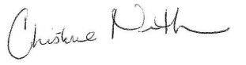
Christine Niemuth, Prevention Coordinator
Bureau of Prevention Treatment and Recovery
Division of Care and Treatment Services
Wisconsin Department of Health Services

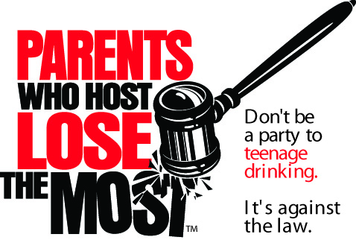
To be considered for free materials, applications must be received at the Wisconsin Department of Health Services, Bureau of Prevention Treatment and Recovery, no later than Friday, December 16, 2016. Applications received after this date may still be considered, depending on available resources. Applications received by December 16 will be given first priority.
2017
Campaign Application and
Materials Request

This project requires the applicant to undertake each of the three following activities. Submission of this application indicates that all three activities are planned:

- Parents Who Host, Lose the Most: Don’t be a party to teenage drinking public information campaign.

- Media advocacy and outreach such as presentations to local civic groups, signs at local retailers and press releases sent to local newspapers, radio and TV stations.

- Law Enforcement participation, including targeted operations to prevent and reduce underage alcohol use during prom and graduation celebrations.

I affirm that all three of the activities listed above will be implemented as part of the campaign.

Signature: Date Signed:

Print Name:

1. Coalition/Organization/School District Name:
Are you applying on behalf of an Alliance for WI Youth Coalition? Yes No
2. County and community(ies) part of the proposed campaign
(Example: Smith County, Village of Smallville):

3. Lead agency or fiscal agent, if any:
4. Coalition/Organization/School District Website:
5. Contact Information: (provide 2 contacts)
Name | Name
Day Phone | Day Phone
Email | Email

6. Shipping Address (Street address. DO NOT use a PO Box. Requested materials will be sent to this address): Agency/Organization Name:
Street Address:
City, State, Zip:

7. Successful applicants are required to have both law enforcement and the local media involved in their campaign. The following groups represented on the project planning team will help the campaign to be more comprehensive by disseminating the information to the whole community. Project planning team should include as many groups as possible in planning and implementation. Indicate which of these groups are represented in your campaign:

Law enforcement Local Media Sources
School District Coalition
Health Care District Attorney
Parent Group Service Clubs
Local Public Health Departments (CHIA)

Others – identify:

8. Did this applicant apply for and receive free materials to participate in the 2016 PWH campaign?
Yes No Unknown

9. Indicate the participating law enforcement agency(ies) and contact person(s) below:

Contact #1 Name | Contact #2 Name | Contact #3 Name
Email Address | Email Address | Email Address
Agency Name | Agency Name | Agency Name

Please return this application no later than Friday, December 16, 2016, to:
Chino Amah Mbah, Bureau of Prevention Treatment and Recovery
FAX: 608-266-1533
EMAIL: Chino.AmahMbah@dhs.wisconsin.gov

You will receive an email from Chino Amah Mbah confirming receipt of your application. If you have NOT received the confirmation within a week of submitting your application, contact Chino Amah Mbah at the email address above. You will receive separate notification that your application has been approved.

Complete the order form on pages 4 and 5 and submit all four pages with your application. All 4 pages must be received by December 16, 2016 to receive materials. Communities may amend their order if additional materials are available. Applications received after December 16 will be considered if materials are available.
Campaign Planning and Materials Order Guide - 2017

Coalition/Organization/School District Name:

Primary Contact and Daytime Telephone:

How much material may each applicant order?
Each successful applicant will receive Parents Who Host Lose the Most promotional material at no cost to the applicant. Amounts are limited and applicants should keep their orders within the proportional guidelines listed below.

Each item has been assigned a value called a credit. The total number of credits available to each applicant is based on the population of the proposed campaign. For example, a county-wide coalition may propose a campaign limited to the county seat. Accordingly, the total amount of credits should be based on the population of the county seat. If that same county-wide coalition decided to operate a campaign in two villages and the surrounding towns, the total population of both villages and towns would determine the number of purchase credits available to the group.

Applicants may target a portion of a community, such as the area around a specific school or neighborhood. A group may order less than the maximum allowable amount. If two applications are proposing to serve the same geographic area there will be an expectation to coordinate efforts and work together.

INDICATE YOUR TARGET POPULATION SIZE

Population (Check One)
Less than 1,000 = 125 credits
1,001 - 5,000 = 150 credits
5,001 - 10,000 = 200 credits
10,001 - 20,000 = 300 credits
20,001 - 50,000 = 700 credits
50,000 - 100,000 = 1,000 credits
100,000 + = 1,500 credits
* Logo Stickers (2 ⅜ inch squares)
Possible uses: Place on school activity programs, church bulletins, envelopes for utility bills or other municipal and civic mailings.
Available in rolls of 100: rolls @ 5.0 credits each = credits
* Logo Window Clings (3 ¾ x 7 ½ rectangular)
Possible uses: Place on the refrigerator cases in convenience stores, grocery stores, gas stations and other locations licensed for beer and alcohol sales for off-premises consumption. Place on the front doors and storm doors of families supporting the campaign.
Available individually: window clings @ 0.8 credits each = credits
* Yard Signs (Vinyl signs with ground wires)
Possible uses: Place in yards near high schools, shopping areas, homes of families agreeing to chaperone substance-free youth events in your community. Signs can be reused from year to year. Move around for maximum impact.
Available individually: signs w/wires @ 5.0 credits each = credits
* Banner (Large 36 x 48 inches)
Possible uses: Hang outside frequently travelled area such as in front of library, city hall, or police station. Hang across a street (permit may be required). This banner may be reused from year to year.
Available individually: banners @ 40.0 credits = credits
* Preprinted Posters are no longer being provided. You can access a PDF version of the poster that can be downloaded and printed as needed at: https://www.dhs.wisconsin.gov/aoda/pwh-wi-poster.pdf
Total Credits Calculation
Logo stickers total credits
Logo window clings total credits
Yard signs total credits
Banners total credits
Total Credits
If the total number of credits exceeds the allowable number of credits noted on page 3, your order may be reduced to fall within the guidelines.

NOTE: If additional quantities of materials become available, list the NUMBER OF EXTRA FOR EACH of the materials you would like to order beyond your credit allocation, and tell us how you would plan to use them.

ADDITIONAL Materials requested: Logo stickers: Yard signs:

Logo Window clings: Banners:

Explanation for use of these extra materials:

"Parents Who Host, Lose The Most: Don't be a party to teenage drinking" is a registered trademark of Drug Free Action Alliance and is used with permission.

