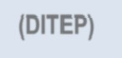
P

00am –
Central Christian Church in Beloit
2460 Milwaukee Ave
June 13-14, 2016

The purpose of this two-day training is to enable education and other professionals to identify chemically impaired individuals and types of drugs for the purpose of ensuring a safe environment.

Day 1 is general information which includes: Introduction and overview
Drugs in society
Policy, procedures, and roles Drug identiﬁcation
Drug categories and their observable eﬀects Issues involving the law
Day 2 is skills training which includes: Eye examinations
Vital signs
Divided attention tests Poly-drug use Assessment process

Objectives of this training are the following:
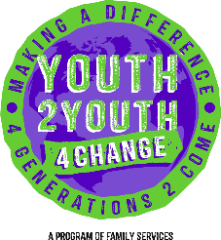
Describe the involvement of drugs in school, organizations and society Name the seven drug categories and recognize their eﬀects Describe drug impairment signs and symptoms
Properly interpret the results of your observations

Who should attend:
Educators, School Nurses, Administrators, Law Enforcement, Parents, Non-Proﬁts and Youth Serving Organizations.

REGISTRATION
There is no cost to attend. Participants will receive manual and lunch.

Participants must register by June 10, 2016 PLEASE NOTE: WHEN REGISTERING – PLEASE REGISTER FOR BOTH DAYS. THIS IS A TWO DAY COURSE
Register at: http://ditep_beloit.eventbrite.com

