Welcome Applicant;
Thank you for your interest in the Alliance for Wisconsin Youth (AWY). The Alliance brings together coalitions, individuals and resources to promote positive youth development through efforts that reduce alcohol and other drug abuse.
The program is supported by the Wisconsin Department of Health Services, Division of Care and Treatment Services in the Bureau of Prevention Treatment and Recovery. The AWY is made up of more than 90 local community coalitions who represent at least five community sectors in Wisconsin. The Alliance for Wisconsin Youth’s purpose is to enhance and support the capacity of its members who work to promote substance abuse prevention and healthy youth development.
Benefits of being an AWY member are many. Alliance for Wisconsin Youth provides technical assistance, training, consultation, and referral opportunities. These opportunities are supported through AWY Regional Prevention Centers to help build local capacity for positive change. To apply to be a member of the AWY community, please complete the application and submit it to mary.haralampopoulos@wisconsin.gov.
Sincerely,
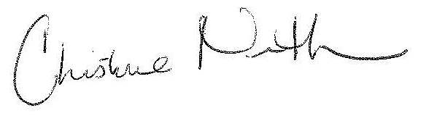
Christy Niemuth, Chair
Alliance for Wisconsin Youth

Application instructions: The application requires you to provide the name of your local coalition, contact information and answer the following narrative questions. Please attach a copy from the most recent meeting minutes and a list of members with their agency affiliations. After completing the application please submit it to mary.haralampopoulos@wisconsin.gov. Thank you.
Local Coalition Name:

Contact information:
Key/ Primary Contact: |  | Secondary Contact
Name |  | Name
Organization |  | Organization
Organization  Address |  | Organization  Address
City |  | City
Zip code |  | Zip code
County |  | County
Daytime Phone number |  | Daytime Phone number
Fax number |  | Fax number
Email |  | Email

Narrative questions
- When was your local coalition established? Please indicate month and year.

- What is the mission of your local coalition?
- What are the goals, objectives and main activities of your local coalition?
- How do youth and adults work together within your local coalition?

- Are the activities of your local coalition funded and/or staffed? If yes, how?

- What community sectors do members of your local coalition represent? In order for your application to be accepted, at least five (5) different groups must be represented. Check all that apply.
Youth
Parents
Business Community
Media
Schools
Youth-Serving Organizations
Religious or Fraternal Organizations
Law Enforcement
Civic & Volunteer Groups
Healthcare Professionals, including mental health and substance
abuse
State, Local and/or tribal government agencies
Other organizations involved in reducing substance abuse

- How often does your local coalition meet? Please include meeting dates of the past 12 months.

Thank you for applying for membership to Alliance for Wisconsin Youth. Remember to attach a copy from the most recent meeting minutes and a list of members with their agency affiliations. Submit complete application to mary.haralampopoulos@wisconsin.gov.
Alliance State Partner

